CODE:
<!DOCTYPE html>
<html lang="en">
<head>
<meta charset="UTF-8">
<meta name="viewport" content="width=device-width, initial-scale=1.0">
<title>responsive web</title>
<style>
.login{
font-size: medium;
font-family:Cambria, Cochin, Georgia, Times, 'Times New Roman', serif;
font-weight: bold;
text-transform: capitalize;
display: flex;
justify-content: center;
align-items: center;
padding-top:100px;
padding-left: 30px;
padding-right:30px;
}
form{
border-style:outset;
border-color:thistle;
border-width:3px;
padding:40px;
background-color:steelblue;

}
#logo{
position:relative;
top:-30px;
left:30px;;
}
@media(min-width:600px) and (max-width:900px){
form
{
background-color:teal;

}
}
@media(min-width:450px) and (max-width:600px){
form
{
background-color:slateblue;

}
}
footer{
color:seashell;
}

</style>
</head>
<body>
<div class="login">
<form>
<input type="image" src="download.png" width="120px" height="120px" id="logo"/>
<br>
<br>
<label>Name</label>
<br>
<input type="text" name="name" required>
<br>
<br>
<label>password</label>
<br>
<input type="text" name="password" id="password"
pattern="(?=.*\d)(?=.*[a-z])(?=.*[A-Z]).{8,}"
title="Must contain at least one number and one uppercase and lowercase letter, and at least 8 or more characters" required>
<br>
<br>
<input type="submit" value="submit">
<br>
<br>
<br>
<footer>
<h2>www.login.com</h2>
</footer>
</form>
</div>
</body>
</html>

OUTPUT:
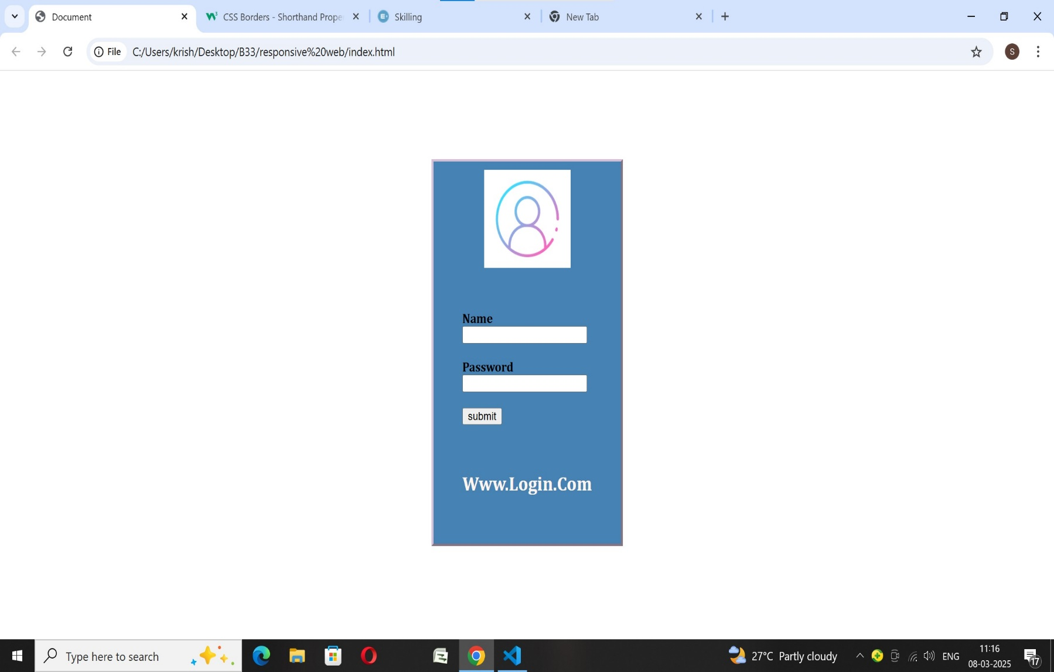
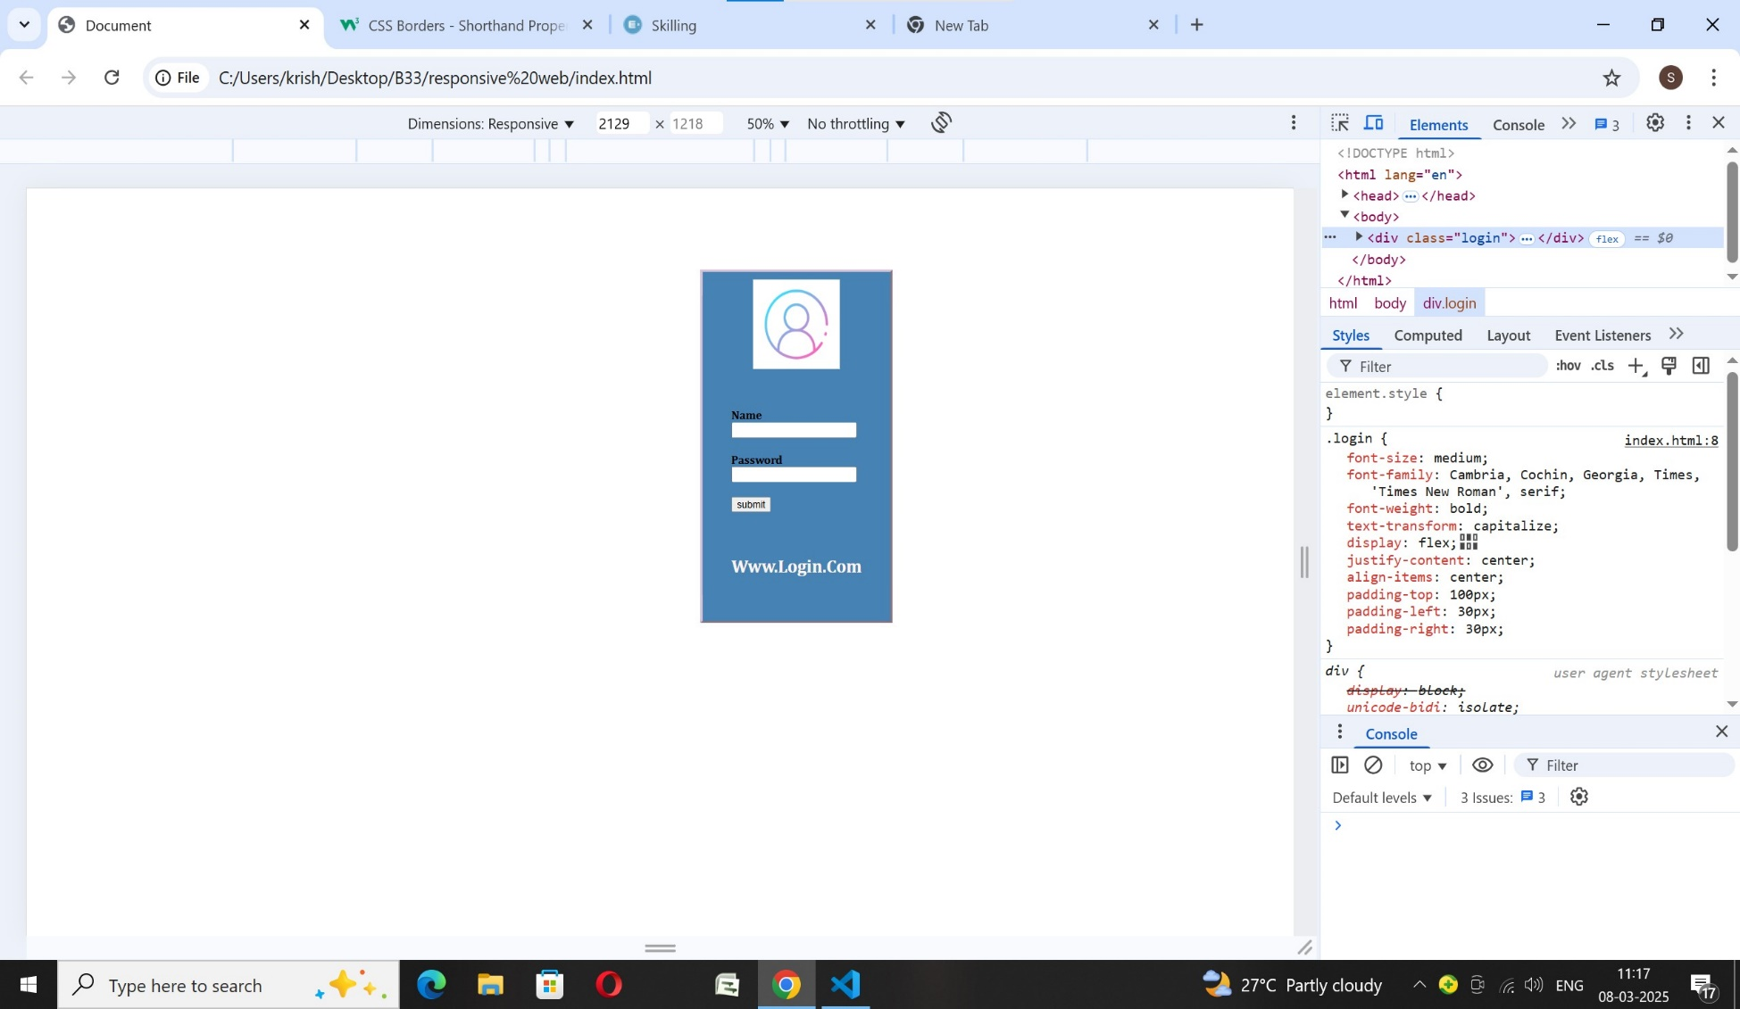
MOBILE PHONE WIDTH:(450PX TO 600PX) OUTPUT:
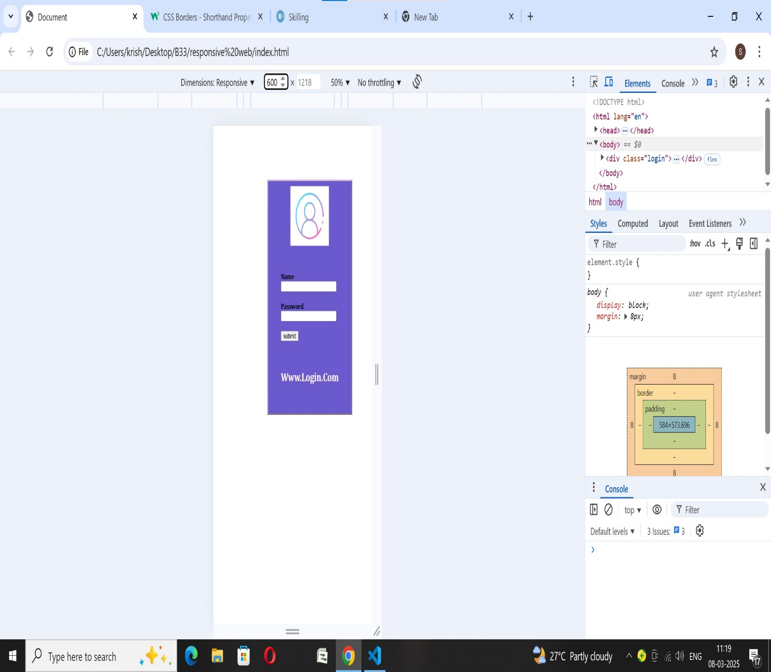

TABLETS WIDTH:(600PX TO 900PX) OUTPUT:

